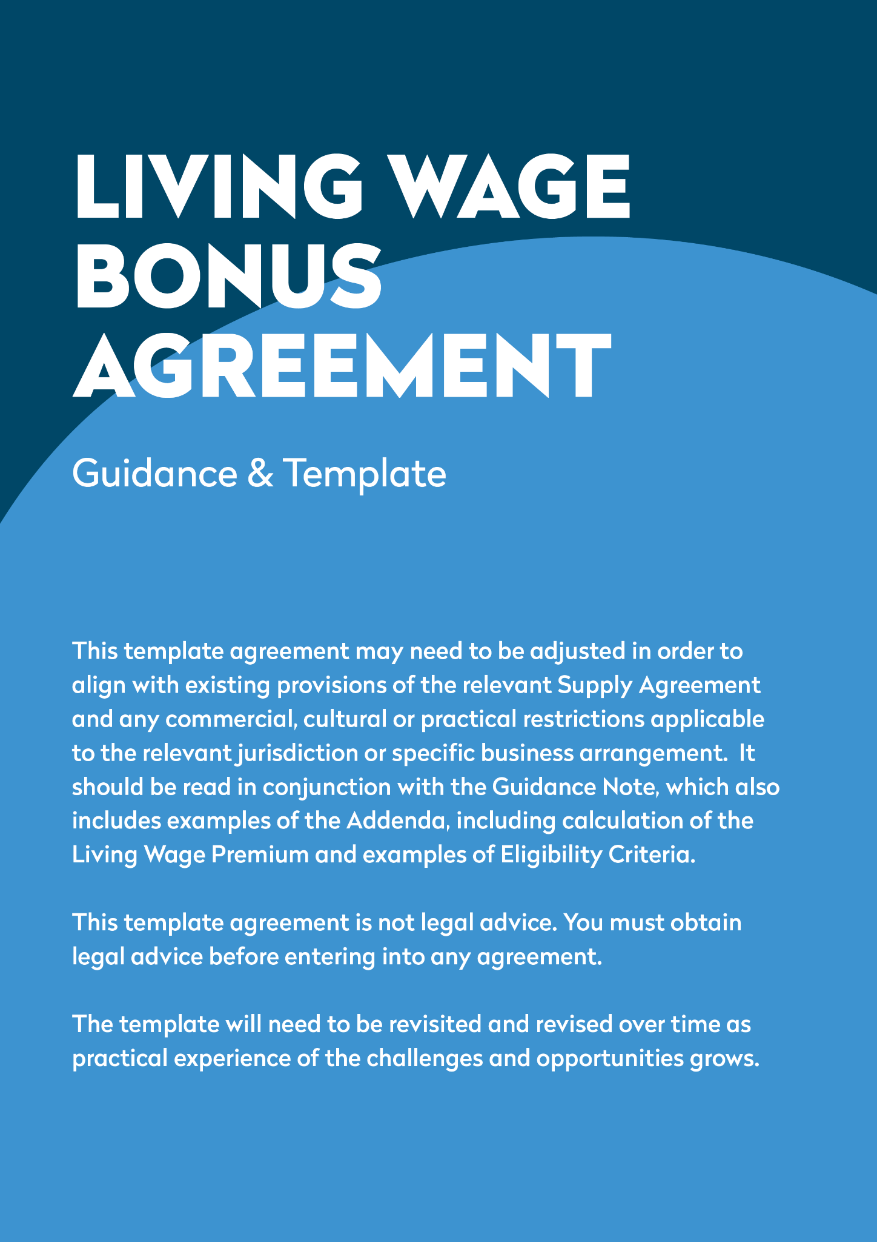

This Agreement is made between:
- [Company Name] whose registered office is at [address] (hereinafter “Buyer”)
and
- [Company Name] whose registered office is at [address] (hereinafter “Manufacturer”)
Buyer and Manufacturer are collectively referred to as the “Parties” and individually as a “Party”. References to the Buyer and Manufacturer in this Agreement shall also include reference to their agents, as appropriate.
This Agreement enters into force on the date of the last signature of a Party (“Commencement Date”). It must be read in conjunction with the [[INSERT] Agreement] (“Supply Agreement”). It sets out the terms on which Buyer and Manufacturer will agree, pay and distribute a Living Wage Bonus to Eligible Employees, and how Manufacturer will be expected to be able to prove it has done so.

- Purpose
  - The aim of this Agreement is to improve the living standards of Employees who perform work at the [[INSERT] description of Factory – this may be multiple premises, to ensure inclusion of relevant subcontractors and/or agents, if applicable] (“Factory”) which manufactures [[INSERT] description of product] (“Product”) which the Manufacturer sells to the Buyer under the terms of the Supply Agreement.
  - The Parties enter into this Agreement in good faith and relying on each other’s commitment to achieve this aim in a collaborative manner. In particular (but without limitation), this means that:
    - all steps to be taken under this Agreement shall be taken expeditiously and in good faith; and
    - in the event of any issues or disputes arising under this Agreement (including where there is an actual or potential breach by either Party) the Parties shall:
      - notify the other party in writing as soon as reasonably practicable; and
      - provide such documentation or other information as may be required to resolve the issue promptly and in good faith; and
      - cooperate to find a swift and beneficial solution which is aligned with the aim of this Agreement, utilising internal and third-party experts and/or mediators to facilitate an agreement where necessary.
- Calculation of the Living Wage Premium
  - The Living Wage Premium is the amount which the Buyer shall pay to the Manufacturer, in addition to the agreed price for each Product payable under the Supply Agreement. The Living Wage Premium is designed to recognise the cost of the labour expended in the manufacture of the Product, according to generally accepted living wage standards. The Living Wage Premium is to be distributed in accordance with the terms of this Agreement.
  - The Manufacturer shall [(and procure that any agent or contractor shall)] collaborate with the Buyer to provide the Buyer with such information as is necessary to calculate the Living Wage Premium, as soon as reasonably practicable, following signature of this Agreement.
  - The Parties agree that appropriate individuals from the Buyer and the Manufacturer [(and/or its agents and subcontractors)] shall attend and participate in evaluation meetings which shall discuss relevant topics including: cost of living estimates in the country, output per month or day on the Buyer’s production lines, the number of workers and the average wage level paid in the assembly department, based on a [forty (40)] hour work week.
  - The Living Wage Premium shall be calculated by the Buyer, taking this information into account. The calculation shall be set out in a new Addendum 1 to this Agreement.
  - The calculation and the amount of the Living Wage Premium may be updated following the Review process set out in article 7 below.
- Eligibility requirements
  - Employees refers to all workers[, including direct and indirect hires (namely, agency workers, temporary workers, contractors, dispatched workers, students, interns etc.)] at the Factory [irrespective of whether they are or not performing services for Buyer or for other companies].
  - The Eligibility Requirements are the requirements which shall determine whether or not an Employee is entitled to receive a proportion of the Living Wage Premium as a Living Wage Bonus (as defined below), and what that proportion will be. Following the process set out below, the Eligibility Requirements will be set out in a new Addendum 2 to this Agreement.
  - Employees who are eligible to receive payment of the Living Wage Bonus, according to the Eligibility Requirements, are referred to below as Eligible Employees.
  - The Living Wage Bonus is additional payment, to be made to Eligible Employees, independent of any other salary, payment, bonus or allowances or other monies to which the Eligible Employees may be entitled to be paid by the Manufacturer [(its agents or subcontractors)] as a result of their employment or engagement.
  - Following the determination of the amount of the Living Wage Premium, the Manufacturer shall [(and shall procure that its agent and/or subcontractor shall)] consult on the Eligibility Requirements and seek to agree them with the Employees.
  - The consultation shall:
    - be organised at (or across) a time and in a manner that it is accessible to all Employees;
    - determine the frequency with which Living Wage Bonus payments shall be paid to Eligible Employees and the dates of payment; and
    - be free and fair.
  - The Manufacturer shall [(and shall procure that its agent and/or subcontractor shall)] ensure that Employees who participate in the consultation process:
    - do not suffer any disadvantage or detriment as a result of their participation in the consultation process and/or as a consequence of any legitimate views that they may express during the consultation process (subject always to any anti-discriminatory or equality laws or other legal requirements that may be applicable); and
    - are paid according to their normal remuneration for any hours that they may spend participating in the consultation process.
  - It shall be made clear to the Employees that the purpose of the Living Wage Bonus is to improve the rates of pay, the quality of life of Employees and drive worker satisfaction and retention at the Factory. Employees shall also be made aware of any relevant information in the Manufacturer’s [(its agents or subcontractors’)] possession which may assist in the consultation, for example (but without limitation):
    - calculations showing what a living wage for the Employees would be and the basis of that calculation (including the information included in Addendum 1); and/or
    - rates of pay for different roles of Employees;
    - average and/or expected orders of the Product; and/or
    - calculations of the expected total amount of the Living Wage Premium over (at least) the next 12 months based on average and/or expected orders of the Product.
  - Following consultation with the Employees and subject to their collective or majority agreement, the Living Wage Bonus may apply to any or all Employees, irrespective of the production line they work on, [or] their role [or who their direct employer may be]. However, Employees will cease to be eligible if they no longer work in the Factory prior to any instalment of the Living Wage Bonus becoming payable to them in accordance with the remaining terms of this Agreement.
  - The Buyer shall have the right to be present at and participate in the consultation process, and to receive evidence of the consultation process, communications with the Employees and the outcome of the consultation process from the Manufacturer.
  - Within [7] days of the conclusion of the consultation process, the Manufacturer shall:
    - communicate to all Employees, in a manner they are able to understand, and also in writing:
      - the outcome of the consultation process and the Eligibility Requirements; and
      - the method and process by which Employees can express any questions or grievances in relation to the Living Wage Bonus and the Eligibility Requirements; and
    - provide to the Buyer a draft Addendum 2 to this Agreement, setting out the proposed Eligibility Requirements, which shall remain in place unless and until any amended Eligibility Requirements are agreed in accordance with article 7 of this Agreement.
  - The Buyer shall communicate its acceptance of the draft Addendum 2, or raise any issues with the Eligibility Requirements as soon as possible, and in any event within [7] days of receipt of a copy of the draft Addendum 2. The Parties shall cooperate in good faith to agree Addendum 2 as soon as reasonably practicable.
- Invoicing for the Living Wage Bonus
  - Following written notification from the Buyer to the Manufacturer that the Eligibility Requirements as set out in the draft Addendum 2 are agreed, the Manufacturer shall be entitled to begin invoicing the Buyer for the Living Wage Premium (or the amended Living Wage Premium, where Addendum 2 has been updated according to the review process set out at article 7 of this Agreement), which shall be paid by the Buyer in accordance with the usual terms for payment of invoices under the Supply Agreement.
  - At the Buyer’s sole discretion, the Buyer may request that the Manufacturer raise an additional invoice for Living Wage Premium applicable to any periods prior to the date the Eligibility Requirements are agreed (or amended) and specify the amount to be invoiced.
- Living Wage Bonus Payments to Eligible Employees
  - Upon receipt of the Living Wage Premium from the Buyer, acting in accordance with the Eligibility Requirements:
    - [where all or part of the Living Wage Bonus is payable to employees of the Manufacturer’s agents and/or subcontractors, the Manufacturer shall pay such part of the Living Wage Bonus that to the agent and/or subcontractor in a timely fashion and without deduction;]
    - the Manufacturer shall [(and shall procure that any agent or subcontractor shall)]:
      - promptly inform Eligible Employees of the amount of Living Wage Bonus which they will be entitled to; and
      - pay the Living Wage Bonus to Eligible Employees via the next available payroll (or other payment which may become due) after receipt of the monies from the Buyer, without deduction, save for any deduction of tax and social security contributions the Manufacturer [(or its agent and/or subcontractor)] is required to deduct by law.
  - The Manufacturer agrees [(and shall procure that its agents and/or subcontractors shall agree)] that:
    - the amount paid, or whether or not the Living Wage Bonus is paid, will not be used as an Employee performance incentive or as a disciplinary tool; and
    - the Living Wage Bonus and shall be awarded to Employees exclusively on the basis of the Eligibility Requirements.
  - [The Manufacturer shall have in place a robust and defensible process whereby the Manufacturer regularly verifies that the Living Wage Bonus has been paid to Eligible Employees of its agents and/or subcontractors. Such process shall include the provision of documentary evidence and quarterly random interviews with Eligible Employees of the Manufacturer’s agents and/or subcontractors, performed by the Manufacturer at the Factory. During such interviews at least one Eligible Employee from each agent and/or subcontractor should confirm that they have received in full all monies payable to them under their contract of employment and the Living Wage Bonus.]
  - In the event that any irregularities are uncovered, the Manufacturer shall inform the Buyer as soon as possible in writing.
- Verification checks
  - The Buyer reserves the right to perform verification checks, whether in person at the Factory or remotely from time to time, to ensure the Living Wage Bonus is paid to and duly received by Eligible Employees of the Manufacturer[, its agents and/or subcontractors] in full. The Manufacturer agrees [(and shall procure that its agents and subcontractors agree)] that the verification checks may be performed by the Buyer or by agents instructed by the Buyer.
  - For the purposes of undertaking verification checks, the Manufacturer undertakes to provide [(and shall procure that the Manufacturer’s agents or subcontractors undertake to provide)] the Buyer and/or its agents with:
    - access to the Factory;
    - access to the Eligible Employees;
    - the payroll records of the Eligible Employees or other such records which may verify the payment of the Living Wage Bonus to Eligible Employees;
    - details of any grievances filed in respect of the Living Wage Bonus, and how these were handled and resolved by the Manufacturer [its agents and/or subcontractors]; and
    - such other information, cooperation and assistance as the Buyer or its agents may reasonably request.
  - In the event that the Manufacturer [or its agents and/or subcontractors] fail to comply with article 6.2 above, or the verification checks uncover irregularities in the payment of the Living Wage Bonus to Eligible Employees by the Manufacturer [(and/or its agent or subcontractors)], or the Manufacturer informs the Buyer of any irregularities under article 5.4 of this Agreement, the Buyer may:
    - request additional verification checks;
    - require the Manufacturer to put into place [(and require its agents and/or subcontractors to put in place)] a remediation plan which shall be subject to the approval of the Buyer (acting reasonably); and/or
    - withhold any sums otherwise due to the Manufacturer [(its agents and/or subcontractors)] up to the amount of the irregularity, until such time as the irregularity has been corrected to the satisfaction of the Buyer.
  - The Manufacturer undertakes to [(and procure that its agents or subcontractors undertake to)] conform and cooperate fully with any remediation plan.
- Review
  - Unless notice has been served that either Party intends to terminate this Agreement under article 8.1 below, or the Supply Agreement is due to come to an end within [6 months] or less after the Review Date (as defined below), [on each anniversary of the Commencement Date], or on any other date which may be agreed between the Parties (“Review Date”), the Parties shall use Employee input and production data, as well as details of any grievances filed in respect of the Living Wage Bonus, and how these were handled and resolved among other information, to review:
    - the calculation of the Living Wage Premium; and
    - the payment of the Living Wage Bonus at the Factory, including the amount payable, the Living Wage Bonus payment process adopted by the Manufacturer [(and its agents and/or subcontractors)] and the Eligibility Requirements (hereinafter referred to as the “Review”).
  - The Parties shall repeat the process set out at articles 2.2 to 2.3 and 3.5 to 3.11 of this Agreement. The outcome of the review shall either be an agreement that the current Addendum 1 and Addendum 2 shall remain in force, or a new Addendum 1 and/or Addendum 2 shall be put in place.
- Term and Termination
  - Subject to the remainder of this article 8, this Agreement shall continue until the termination of the Supply Agreement or until it is terminated by either Party on the anniversary of the Commencement Date, having given a minimum of three months’ written notice.
  - This Agreement may be terminated by the Buyer with immediate effect (and without the need for notice) if the Manufacturer [(its agents and/or subcontractors)] has [/have]:
    - committed any material breach or repeated or continued (after warning) any material breach of their obligations under this Agreement; and/or
    - been guilty of dishonesty; and/or
    - provided false information to the Buyer, its agents and/or the Employees; and/or
    - been guilty of conduct calculated or likely or tending to bring themselves, the Buyer or any Group Company into disrepute or otherwise prejudicially to affect the interests of the Buyer or any Group Company.
  - Without prejudice to any other rights or remedies that the Buyer may have, the Manufacturer acknowledges and agrees that damages alone would not be an adequate remedy for any breach by the Manufacturer of the terms of this Agreement. Accordingly, the Buyer shall be entitled to the remedies of injunction, specific performance or other equitable relief for any threatened or actual breach of the terms of this Agreement.
- Communication
  - The Parties shall be permitted to make publicly available information on the existence and terms of, and the payments made under, this Agreement (including Addendum 1, setting out the calculation of the Living Wage Premium, and Addendum 2, setting out Eligibility Requirements).
- Tax and Status
  - The Manufacturer shall [(and shall procure that any agent and/or subcontractor shall)] be fully responsible for and shall indemnify the Buyer and/or any other Group Company for and in respect of:
    - any income tax, national insurance and social security contributions and any other liability, deduction, contribution, assessment or claim arising from or made in connection with the performance of this Agreement or the payment of the Living Wage Bonus to the Eligible Employees in any jurisdiction. The Manufacturer shall further indemnify the Buyer against all reasonable costs, expenses and any penalty, fine or interest incurred or payable by the Buyer or any other company in the Buyer’s corporate group in connection with or in consequence of any such liability, deduction, contribution, assessment or claim in any jurisdiction; and
    - any liability arising from any employment-related claim or any claim based on worker status (including reasonable costs and expenses) brought by any Eligible Employees against the Buyer or any other company in the Buyer’s group arising out of or in connection with the performance of this Agreement, in any jurisdiction.
  - Nothing in this Agreement shall render the Eligible Employees an employee, worker, consultant, agent or partner of the Buyer (and/or any other company in the Buyer’s group) and the Manufacturer shall procure [(and shall procure that its agents and/or subcontractors procure)] that the Eligible Employees shall not hold themselves out as such.
  - This Agreement is not intended to amend or vary the contracts of employment of any Employees or Eligible Employees with their respective employer or entitle them contractually to an increase in salary and/or other benefits or payment of a bonus.
- Miscellaneous
  - This Agreement sets out the entire agreement between the Buyer and the Manufacturer relating to the Living Wage Premium and the Living Wage Bonus and supersedes all prior discussions between the parties and their advisors, and all statements, representations, terms and conditions, warranties, guarantees, proposals, communications and understandings, whenever given and whether orally or in writing.
  - If there is any contradiction between the terms of this Agreement, and the terms of the Supply Agreement, the terms of this Agreement shall prevail.
  - No variation of this Agreement shall be valid unless it is in writing and signed by or on behalf of each of the Parties.
  - Waiver of any right or remedy is only effective if given in writing and shall not be deemed a waiver of any subsequent right or remedy.
  - A delay or failure to exercise, or the single or partial exercise of, any right or remedy shall not waive that or any other right or remedy, nor shall it prevent or restrict the further exercise of that or any other right or remedy.
  - This Agreement may be executed in any number of counterparts each in like form, all of which taken together shall constitute one and the same document and any party may execute this Agreement by signing any one or more of such counterparts. Delivery of an executed signature page of a counterpart by e-mail in Portable Document Format (PDF) shall take effect as delivery of an executed counterpart of this Agreement.
  - This Agreement shall be governed by and construed in accordance with the applicable law and jurisdiction provisions in the Supply Agreement.
Manufacturer Buyer

______________________ ______________________
Name: Name:
Role: Role:
Date: Date:

ADDENDUM 1
[INSERT CALCULATION AS REFERRED TO IN ARTICLE 2.4]

ADDENDUM 2
[INSERT ELIGIBILITY REQUIREMENTS]

Insert reference to the contract to which this Agreement will be attached.
It is important to properly consider and agree the description of the product, or products which are covered by the terms of this Agreement. Products may include all products (including new product) or because of issues around scale and/or other commercial requirements it may be limited to a subset of products. If there is material change to the product, or products to be manufactured, the parties may need to agree to an early review under Article 7.1 and agree to amend the Product description.
Whether this wording (and all wording in square brackets in blue text) is necessary, depends on the definition of Employee – see further clause 3.1 below.
This may include information such as a best estimate of likely order numbers for the Product in the next 12 months or some other time period.
Delete references to agency workers etc. if not applicable. If only direct Employees are to be covered, also remove all other wording in square brackets, in blue text.
Another date may be appropriate if, for example the Parties enter into a new Supply Agreement, or radically increase or decrease the number of Products (expected to be) ordered.
The circumstances in which this Living Wage Bonus Agreement may be terminated may also need to reflect the circumstances in which the Supply Agreement can be terminated.
It may be necessary to take separate tax advice on any tax related implications of making payments for the Living Wage Premium to the Manufacturer.

